To: kimberly.d.hall52.civ@us.navy.mil
Cc (carbon copy): richard.j.harris120.civ@us.navy.mil, jeffrey.d.welch.civ@us.navy.mil, peter.c.burbery.civ@us.navy.mil, peter.cullen.burbery@gmail.com
Subject: Progress Update for 2026-002-005 Thursday
What I did, 2026-002-005 Thursday
Dear Kimberly D. Hall, NM-04 supervisor of 54520 competency, Jeffrey D. Welch, NM-04 supervisor of 54510 competency, Richard J. Harris Jr., ND-04 Scientist of 54520 competency, and Peter Cullen Burbery, ND-03 Scientist of 54520 competency,

I would like to give you a progress report for 2026-002-005 Thursday. I plan to attend Systems Engineering Spotlight (1 CLP) from 13 to 14 tomorrow 2026-002-006 Friday. Once I get this Systems Engineering Spotlight, I will have 39-LANT-New Professional-Master Development Plan-Communities of Interest_Command Events done.

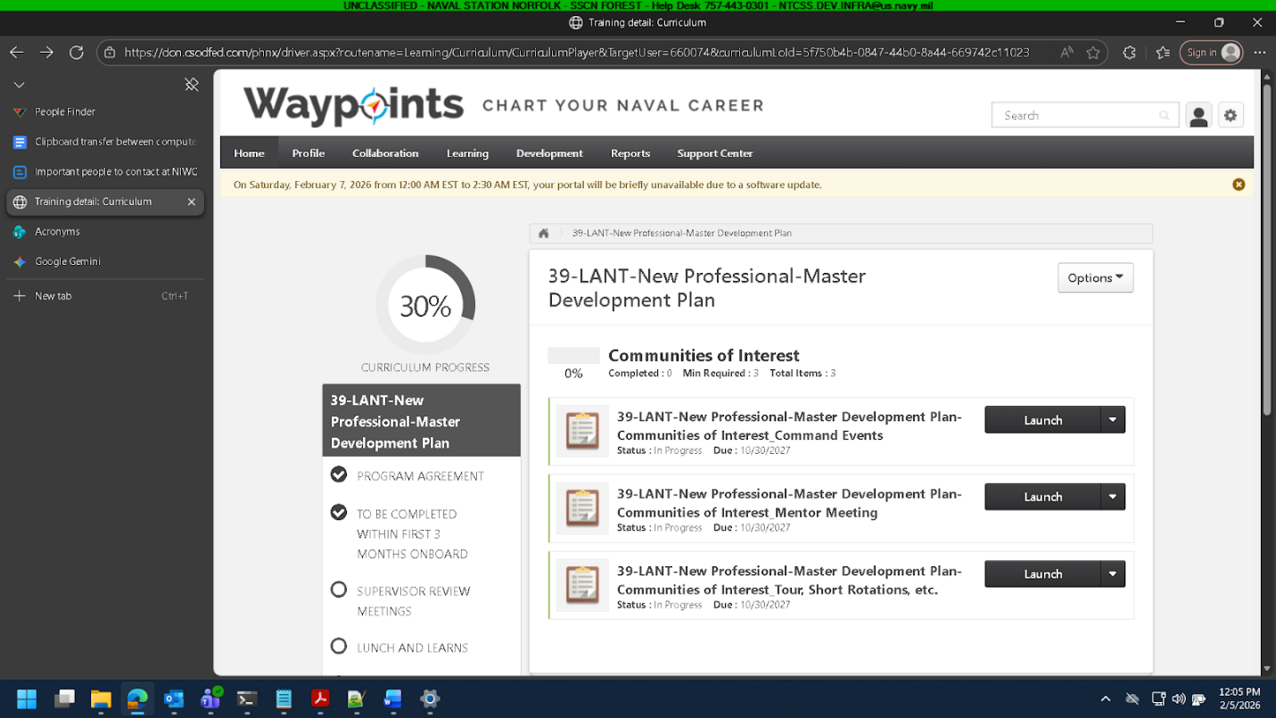

and

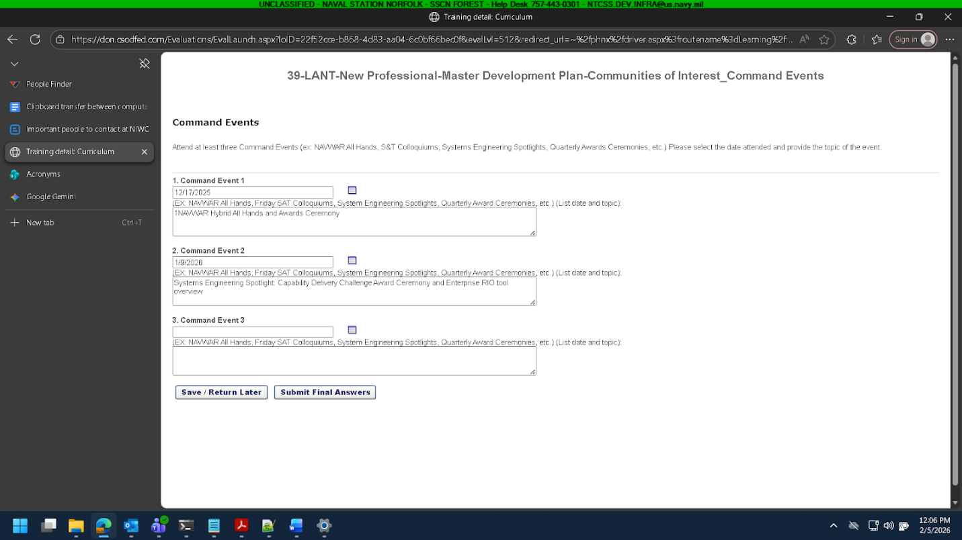

The instructions are “Attend at least three Command Events (ex: NAVWAR All Hands, S&T Colloquiums, Systems Engineering Spotlights, Quarterly Awards Ceremonies, etc.) Please select the date attended and provide the topic of the event.”.

I talked to Richard today about the project.
He introduced me to the workings of the project.

I plan to finish up training on Friday and transition to the project on Monday.

Richard Harris showed me the VDI machine.

Richard Harris showed me the VDI machine and how it works. At least some of it. There’s a lot to learn and cover and learn/cover.

I was shown the test suites.

I worked on the training some. I didn’t make that much progress. I tried to focus, but I couldn’t. Hopefully I will be able to focus better tomorrow. It is difficult to focus when people in cubicles next to me are talking. I wear headphones so when I’m listening to something other people can’t hear me (at least to a degree). I wish they would wear headphones because at least the speakers wouldn’t ‘blare” what the other person is saying.

I don’t want to be a complainer, but it would be great if the other people could wear headphones if there headphones available. I don’t know if I’m going to get retribution for this but it would be great if that could be implemented.

I could move my cubicle but I like my cubicle and other cubicles probably aren’t that much noise different from my cubicle, so it would be great if they could wear headphones so I could focus better.

I have to wear headphones, but other people don’t have to wear headphones because they whatever, which seems like a double standard to me. I guess I’m new here and everything but it would help me if other people could wear headphones. I think it would help.

I think I could do higher-quality work if I could focus better.

But tomorrow I aim to focus on the training and learn Rsupply.

I hoped to get work done on the training today, but I couldn’t focus very well, so I didn’t get much work done.

I was able to get more work done when I teleworked because of the quiet.

Sincerely,

Peter Cullen Burbery

P.S. The main thing that disrupts my concentration is conversations about other projects or whatnot in other people’s cubicles, and its hard to focus when people are carrying on conversations in other people’s cubicles and I can hear every word they are saying.

I am learning more about the project, which is good.

I got some pizza today from 13.30 to 14:00. I would really like it if other people could wear headphones. At least I wouldn’t hear what their responder-partner was saying. I could look into getting some noise-cancelling earbuds, but that’s kind of complicated.

